

**Subject: CSE307 (INTERNETWORKING ESSENTIALS)**

**Name: Chikkepalli Mohammad Noor Baba Section: K23CH(G-2)**

**Roll No.: 63**

**Reg No.: 12303944**

**Submitted To:**

Project63: You are hired as a network engineer for 24/7 Network Solutions, a mid-sized enterprise with a 8-floor office building. Each floor is equipped with 6 computers, and the organization requires a well-structured network to ensure efficient communication and scalability. Network Design Requirements:

1. Topology Selection: Design a star topology for first 3 floors, ring topology for next 3 floors, and mesh topology for remaining floors, considering performance and fault tolerance.

2. IP Addressing Scheme: The company has decided to use Class B private IPv4 addresses for first three floors, Class C private IPv4 addresses for next two floors, and then Class B public IPv4 addresses for remaining floors following a classful addressing scheme. Allocate IP addresses properly for each floor, ensuring uniqueness.

3. Routing Strategy for Inter-Floor Communication & Connectivity: Recommend a routing approach that is dynamic for inter-floor communication. • Design how the floors will be connected for seamless interdepartment communication. • Suggest the appropriate network devices (e.g., switches, routers, access points) and their placement. • If using dynamic routing, suggest an appropriate routing protocol (e.g., RIP, OSPF, or EIGRP) with justification. • If using static routing, define the static routes for efficient data flow. • Specify the number of default gateways along with IP addresses.

**Overview :**

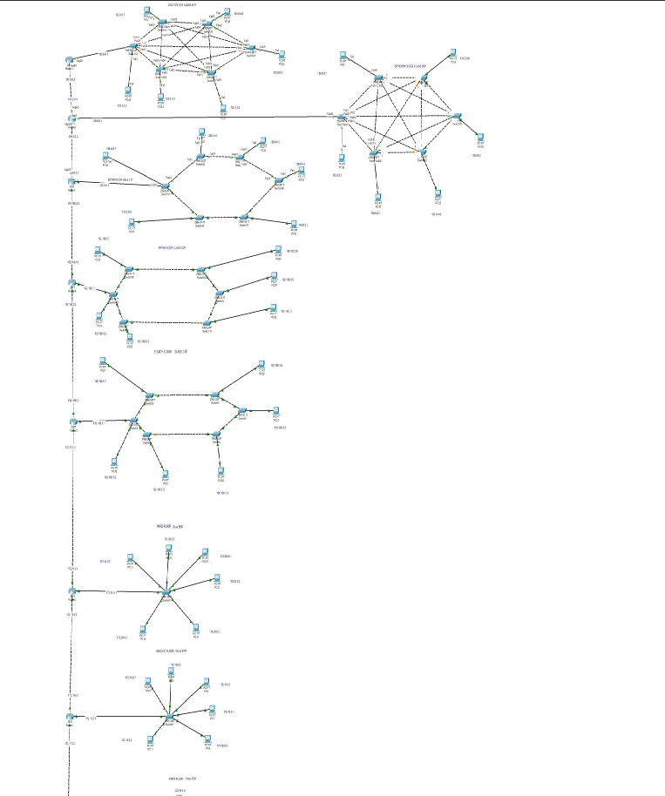

**Physical Scenario**

# FLOOR 1

**1 switch**

**6 computers**

**1 router**

**Using ring topology**

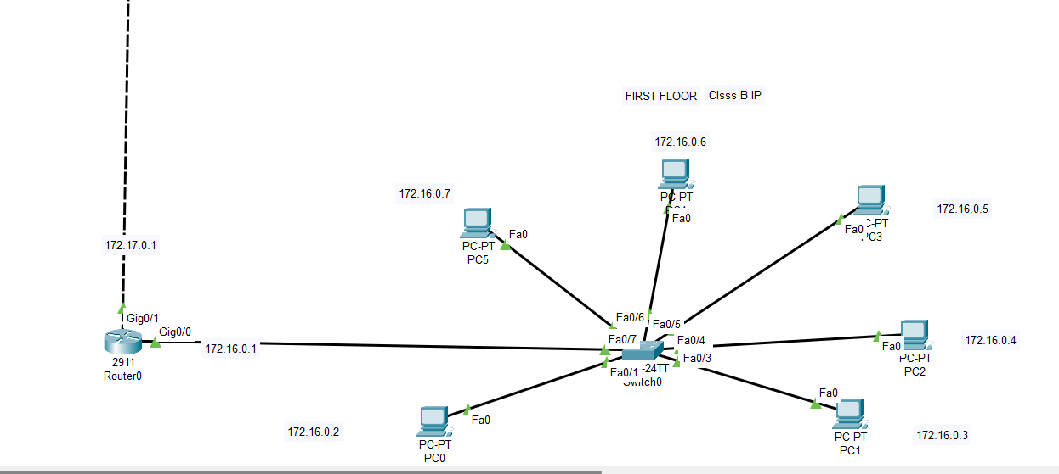

# FLOOR 2

**1 switch**

**6 computers**

**1 router**

**Using ring topology**

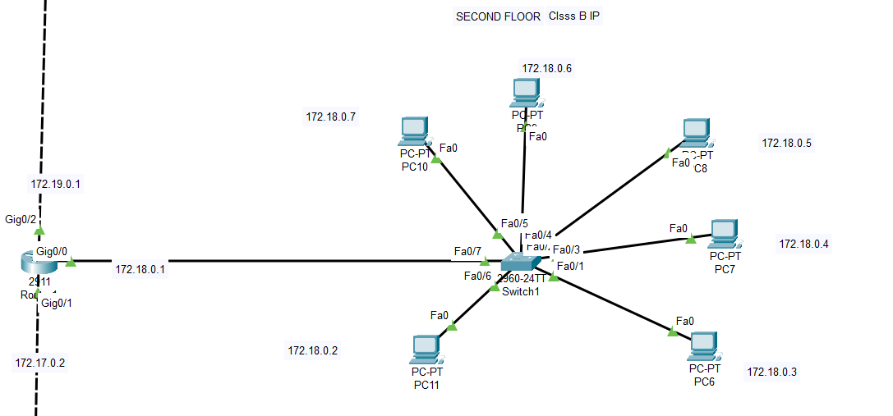

# FLOOR 3

**1 switch**

**6 computers**

**1 router**

**Using ring topology**

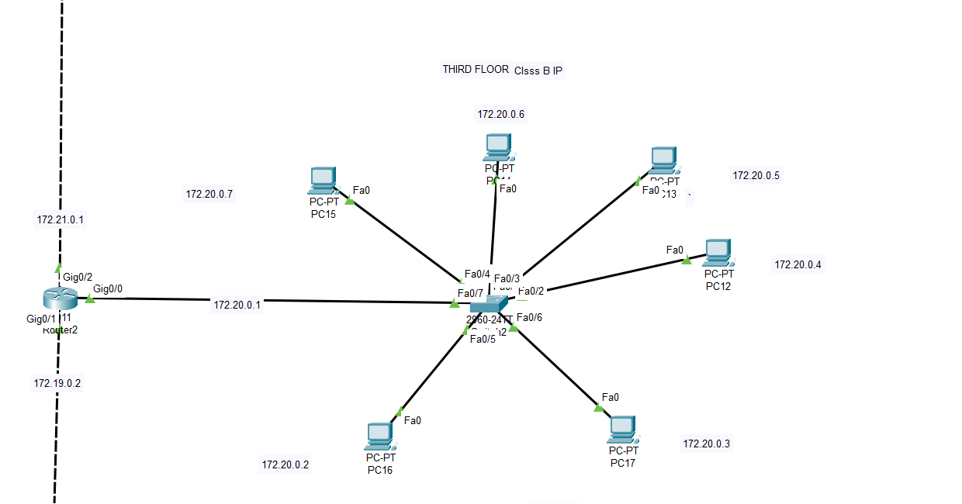

# FLOOR 4

**6 switches**

**6Computers Used Made Using ring topology**

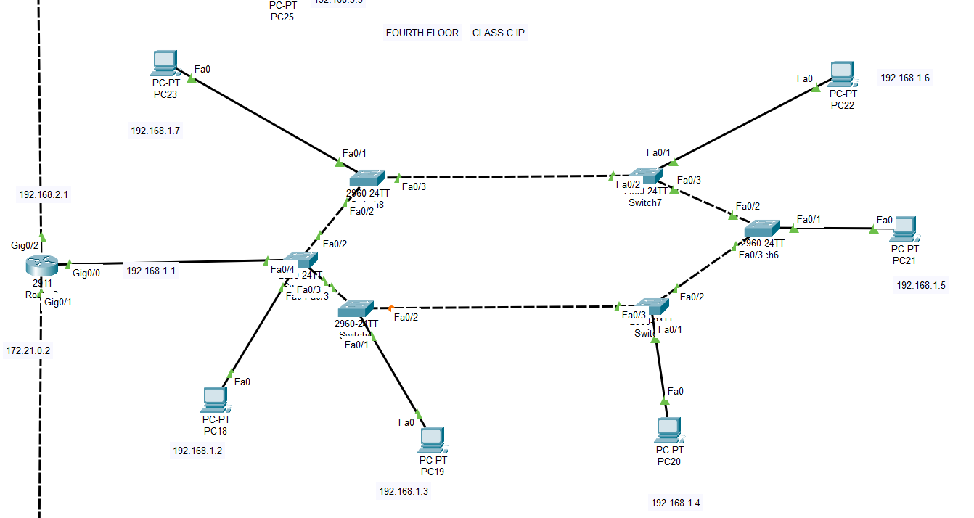

# FLOOR 5

**6 Switch Used**

**6 Computers Used Made Using RING TOPOLOGY**

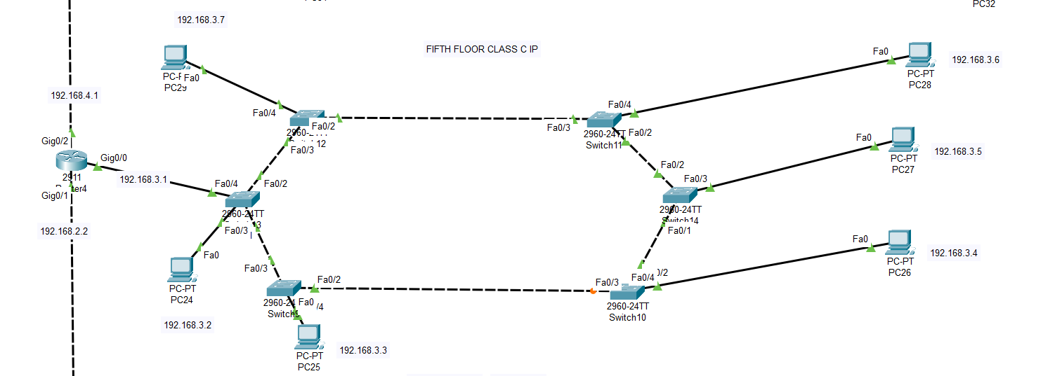

# BUILDING 6

**6 Switch Used**

**6 Computers Used Made Using RING Topology**

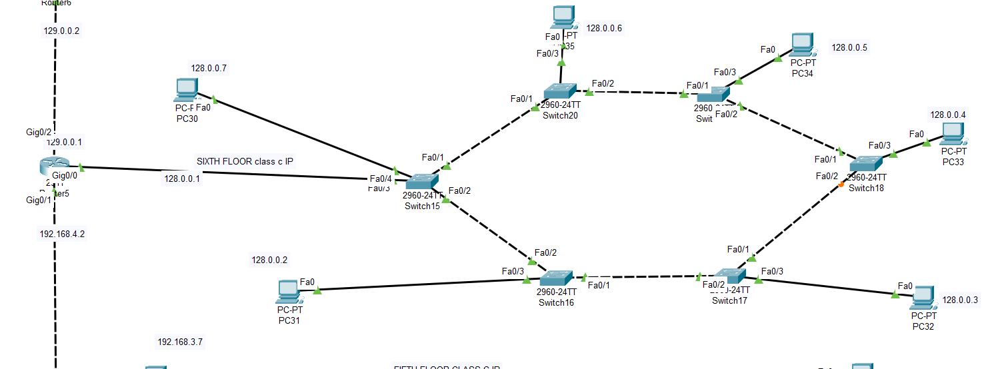

# BUILDING 7

**6 switches Used**

**6 Computers Used Made Using Mesh Topology**

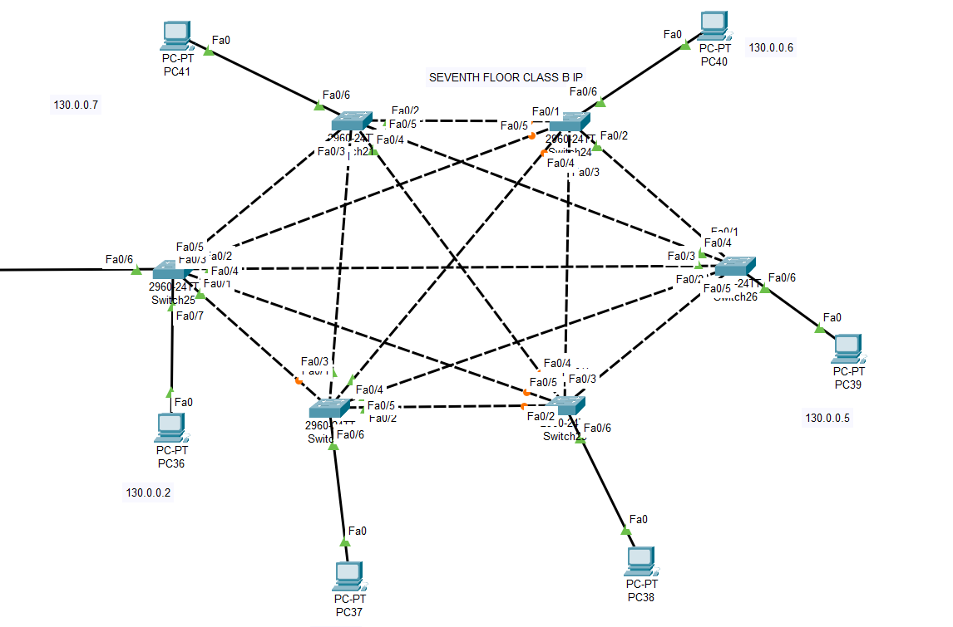

# FLOOR 8

**6 SWITCHES Used**

**6 Computers Used Made Using MESH Topology**

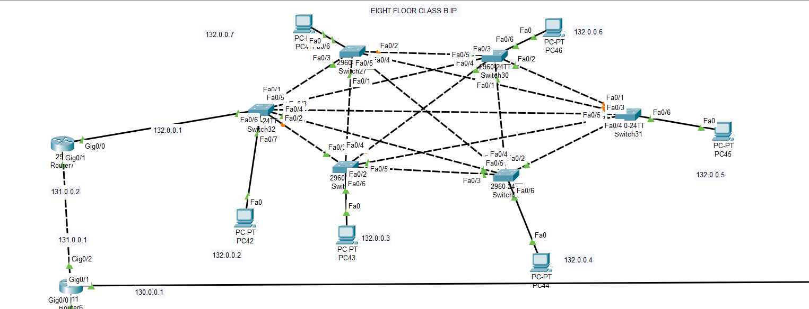

**How I Assigned IP :**

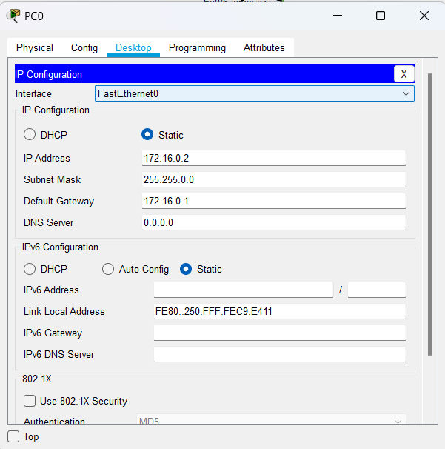

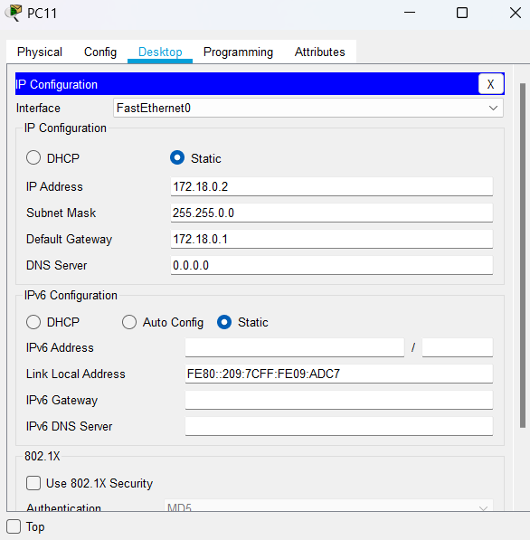

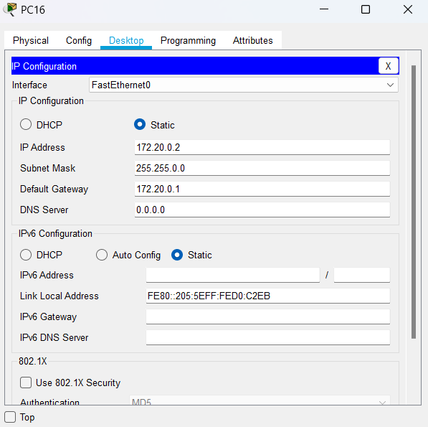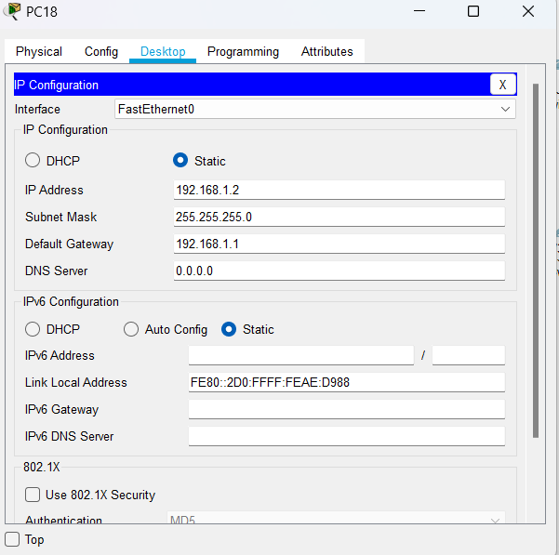

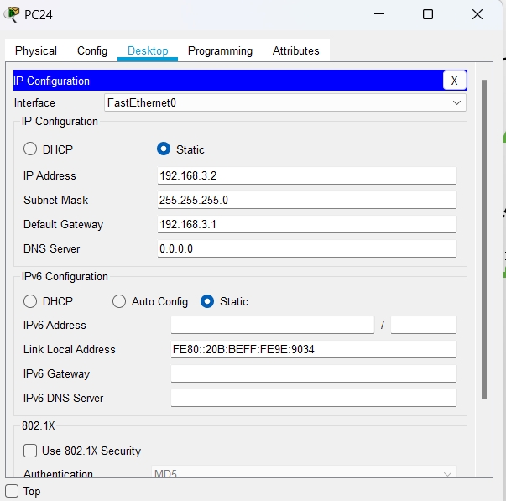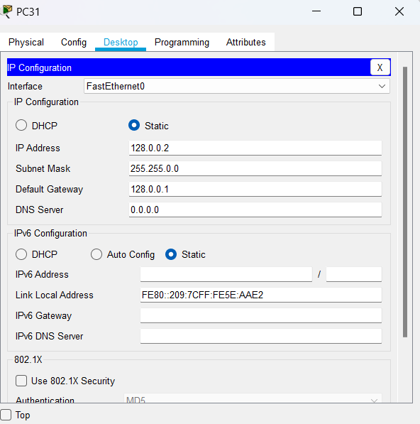

**Routing :**

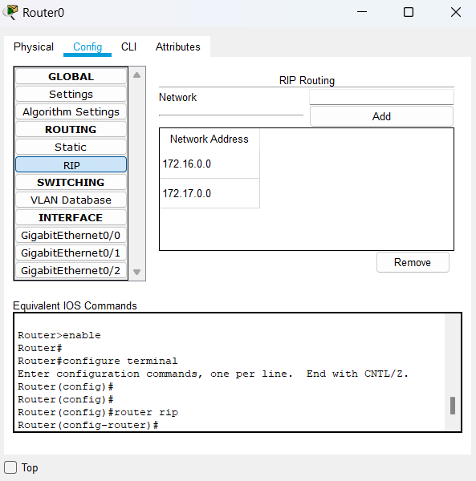

**Communication between PCs**

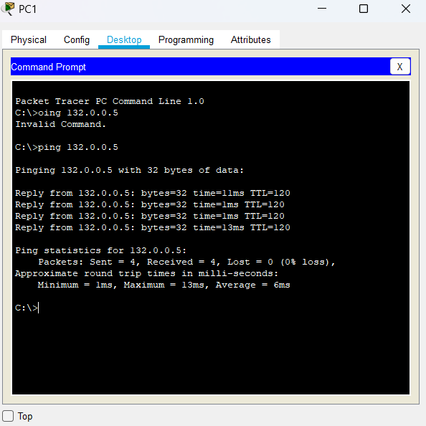

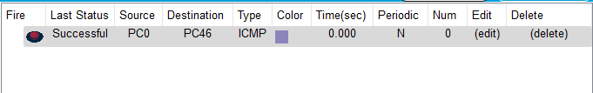

**Thank You**